Q. Create Jenkins job using declarative pipeline, We have three branch in our project repo and we need write pipeline script to clone these branches, create 3 container and deploy respective branch index file on respective httpd server of container.

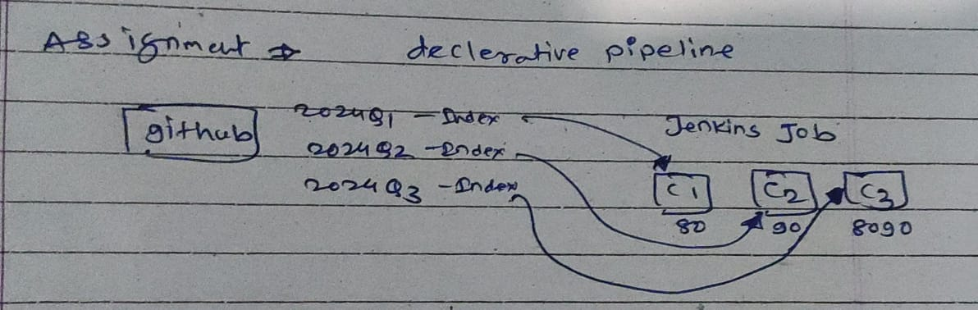

Created ec2 instance

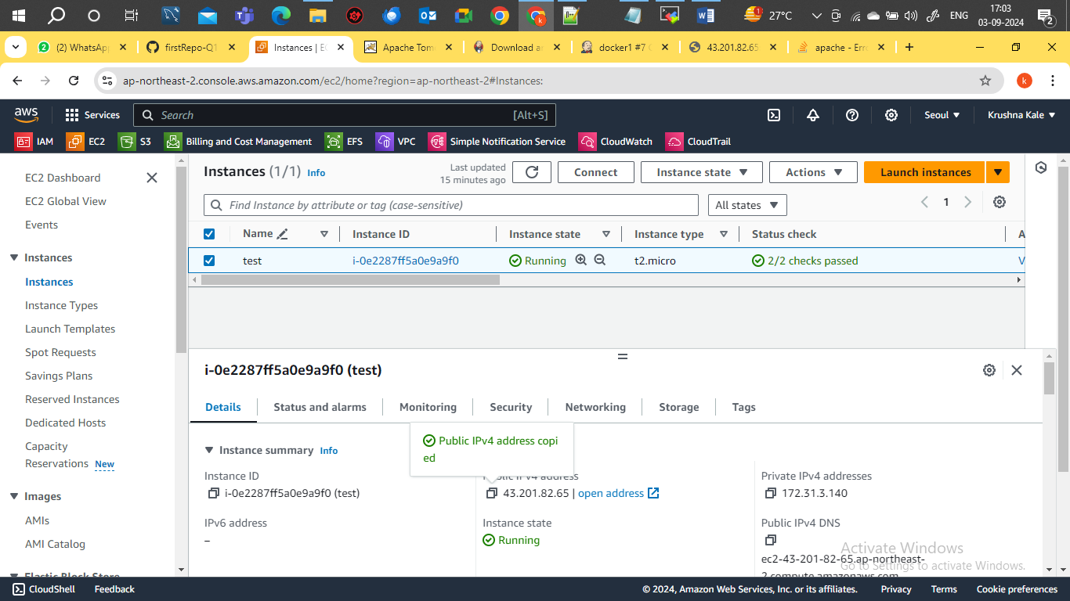

Create pipeline job

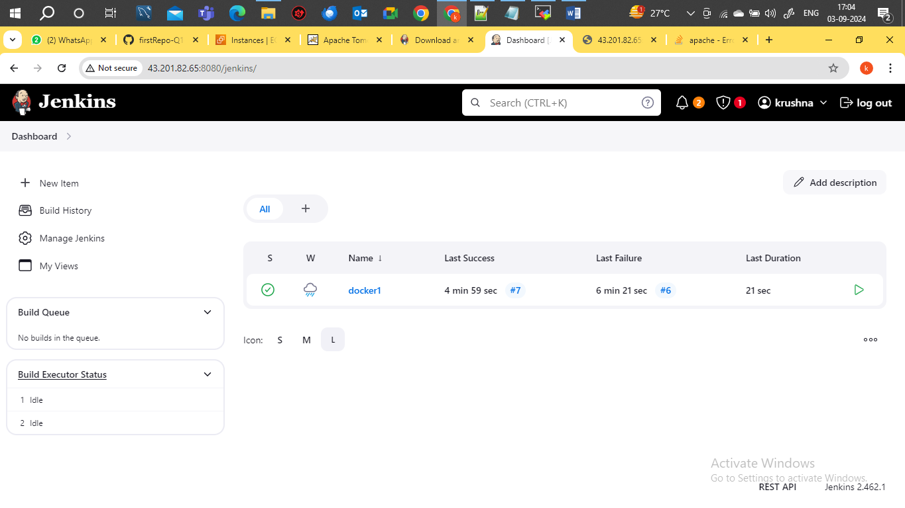

*script*

pipeline{

agent{

label{

label "built-in"

customWorkspace "/mnt"

}

}

stages{

stage("clean_repo"){

steps{

sh "rm -rf 2024Q*"

}

}

stage("clone_2024Q1"){

agent{

label{

label "built-in"

customWorkspace "/mnt/2024Q1"

}

}

steps{

sh "git clone https://github.com/kkale0901/firstRepo-Q1-release.git -b 2024Q1"

sh "chmod -R 777 /mnt/2024Q1/firstRepo-Q1-release/index.html"

}

}

stage("clone_2024Q2"){

agent{

label{

label "built-in"

customWorkspace "/mnt/2024Q2"

}

}

steps{

sh "git clone https://github.com/kkale0901/firstRepo-Q1-release.git -b 2024Q2"

sh "chmod -R 777 /mnt/2024Q2/firstRepo-Q1-release/index.html"

}

}

stage("clone_2024Q3"){

agent{

label{

label "built-in"

customWorkspace "/mnt/2024Q3"

}

}

steps{

sh "git clone https://github.com/kkale0901/firstRepo-Q1-release.git -b 2024Q3"

sh "chmod -R 777 /mnt/2024Q3/firstRepo-Q1-release/index.html"

}

}

stage("container_creation"){

steps{

sh "docker system prune -a -f"

sh "docker run -dp 80:80 --name 2024Q1 httpd"

sh "docker run -dp 90:80 --name 2024Q2 httpd"

sh "docker run -dp 8080:80 --name 2024Q3 httpd"

}

}

stage("deploy_index"){

steps{

sh "docker cp /mnt/2024Q1/firstRepo-Q1-release/index.html 2024Q1:/usr/local/apache2/htdocs"

sh "docker cp /mnt/2024Q2/firstRepo-Q1-release/index.html 2024Q2:/usr/local/apache2/htdocs"

sh "docker cp /mnt/2024Q3/firstRepo-Q1-release/index.html 2024Q3:/usr/local/apache2/htdocs"

}

}

}

}

Github repository

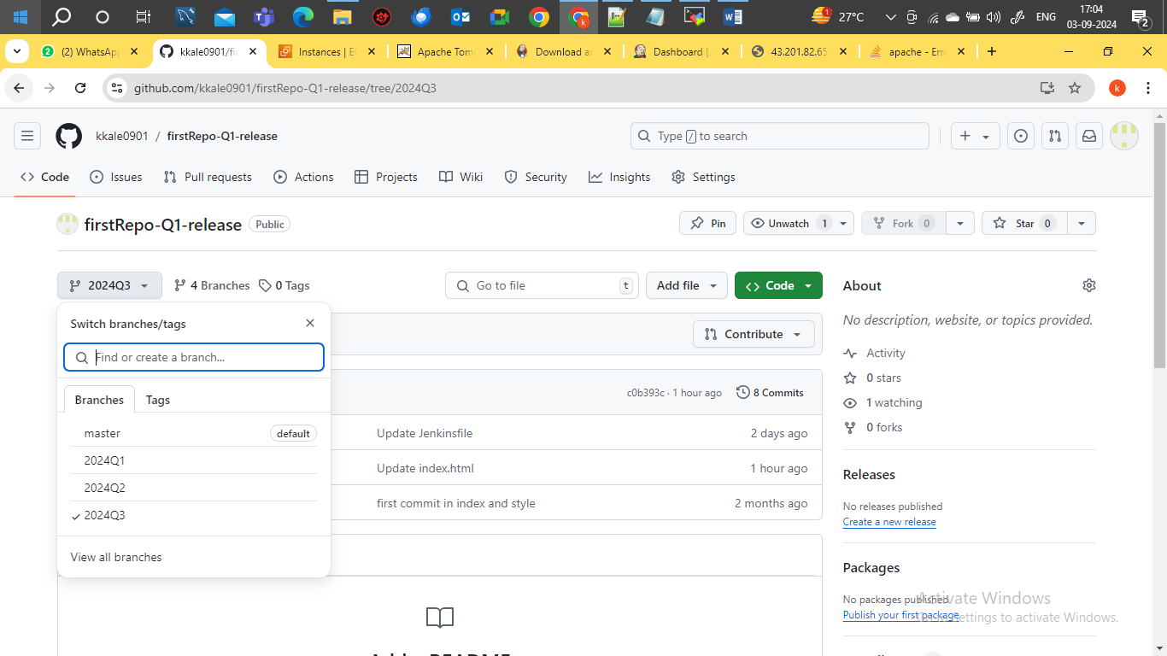

Job build successfully

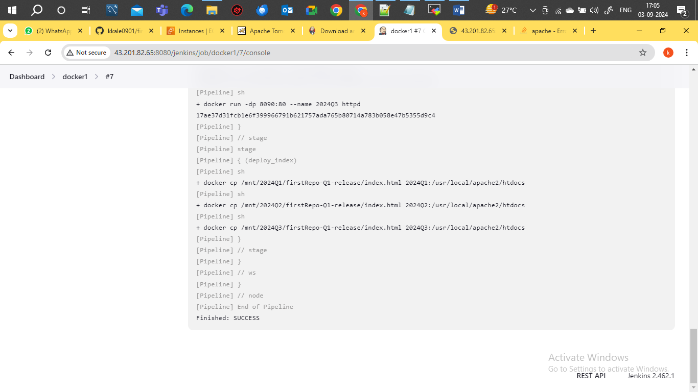

Three container created using script

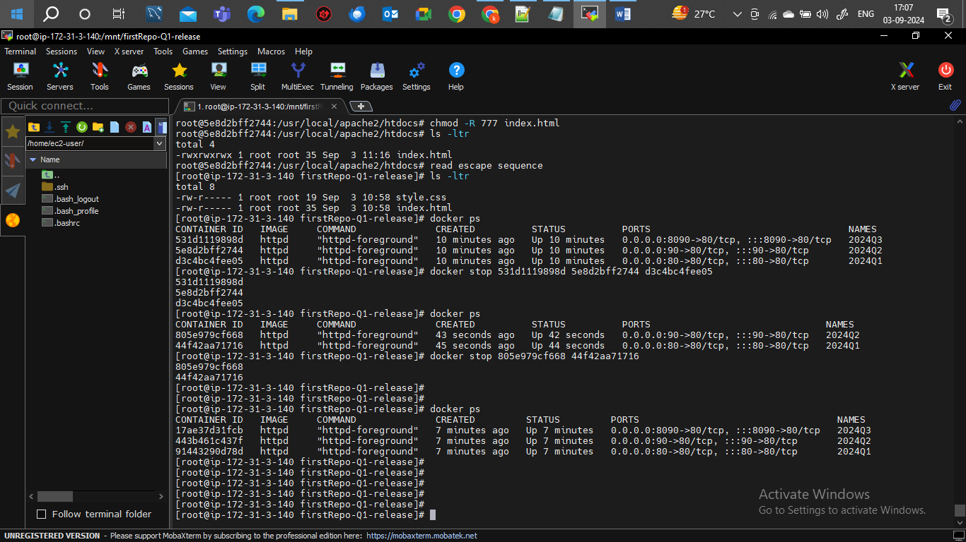

Port binding of 2024Q1 container with Ec2 instance port 80 and confirm the application host successfully

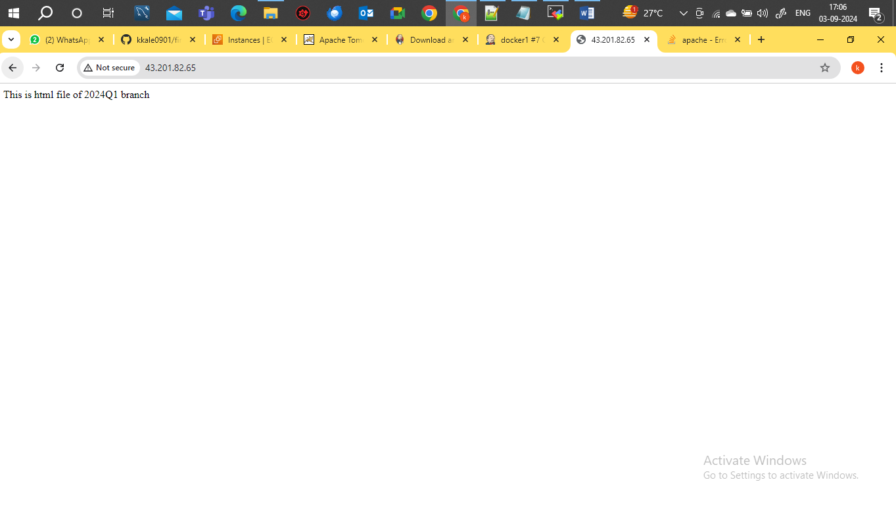

Port binding of 2024Q2 container with Ec2 instance port 90 and confirm the application host successfully

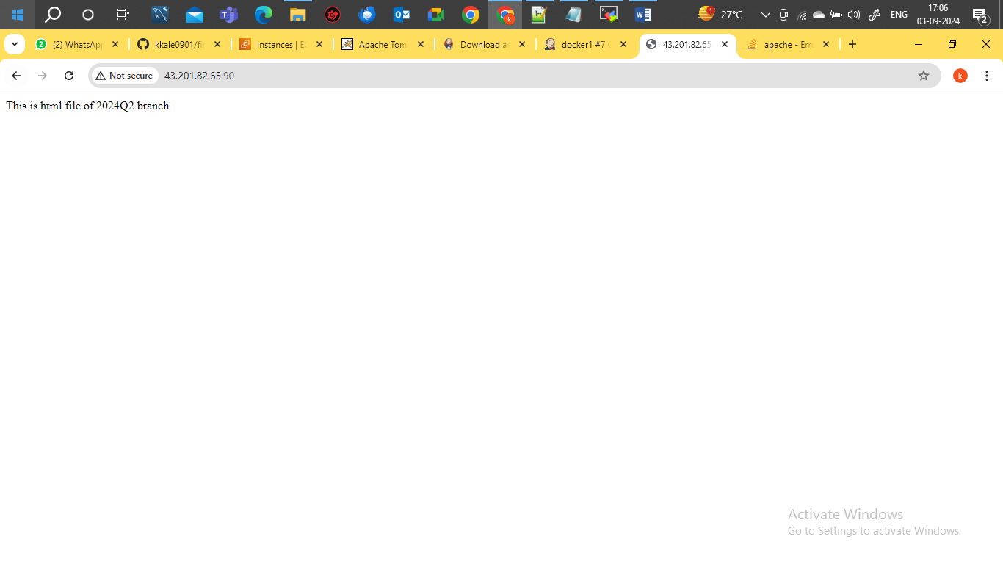

Port binding of 2024Q3 container with Ec2 instance port 8090 and confirm the application host successfully

